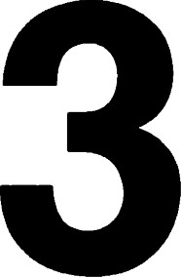Finite groups of isometries of E 2

# Introduction

So far we have been studying particular figures or transformations with only secondary emphasis on the group structures involved. We shall now turn our attention to the study of groups of transformations and apply our results to get geometrical conclusions. Our main result is to determine precisely the finite groups of isometries of E2

# Cyclic and dihedral groups

Let m be any positive integer, and let a — rot (2T/m). The smallest subgroup of 0(2) containing a is denoted by Cm. We observe that Cl = {I} , but if m > 1 then Cm consists of the distinct elements I, a, a 2, m—l, because am = I. Any group isomorphic to Cm is called a cyclic group of order m.

Now let ß = ref 0. The smallest subgroup of 0(2) containing both and ß is denoted by Dm.

Theorem 1. In the group Dm the identity ßa = a -l ß holds.

Proof: By Theorem 1.30 we have, for any 0, (b, ref e rot = ref 0 = ref 0 + 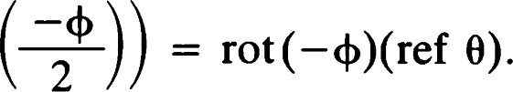

Setting = 2T/m and 0 = 0 yields the desired result.

Theorem 2. The index [Dm : Cm] of Cm in Dm is equal to 2.

Proof: The group Cm consists of m distinct rotations. The coset ßCm consists of m distinct reflections. Because the identity

ßaJßak = a J ß2ak k-j holds, the union of the cosets ßCm and Cm is the group D,n.

Any group isomorphic to is called a dihedral group.

Remark:

1. The symmetry group of an angle (other than a straight angle) is isomorphic to DI. It consists of the identity and a reflection.
2. The Klein four-group (which we obtained in Theorem 2.28 as the symmetry group of a segment) is isomorphic to D2. It consists of the identity, a half-turn, and two reflections.
3. The symmetry group of an equilateral triangle (Theorem 2.37) is isomorphic to 1)3.

# Conjugate subgroups

Let G be a group. Two subgroups H and K are said to be conjugate in G if there exists an element g e G such that K = g -1Hg.

Theorem 3. Let g and T be isometries of E2. Then

i. If T is a reflection, so is g- Tg. ii. If T is a rotation, so is g -l Tg. iii. If T is a translation, so is g -l Tg.

Proof:

1. Let T = Oe be a reflection. For any x e g -l e, g -l Oegx = g- gx = x,

so that g -l e is pointwise fixed. On the other hand, g -l Oeg cannot be equal to the identity. Because it has this particular fixed point behavior, g-lOeg must in fact be the reflection in the line g -l e (Theorem 1.39).

1. Suppose that T = OeO„g is a rotation with center P. Then g -l Tg =

a rotation about g -l p.

1. Suppose that T = OeO„ is a translation. Then g —l Tg is the product of reflections in the parallel lines g -l e and g- m.

Groups of isometries that are conjugate in J(E2) are said to be geometrically equivalent. This definition is motivated by observations of the 72 type made in Theorem 3. Conjugate elements perform the "same" isometries with respect to "different" positions. The group of all rotations Conjugate subgroups about a point P is conjugate to the group of all rotations about any other point Q.

An example of two groups that are algebraically equivalent (i.e., isomorphic) but not geometrically equivalent (conjugate) is given by DI and C2. Because both have order 2, they are isomorphic. But C2 is generated by a half-turn a, and DI by a reflection ß. Any equation of the form g- ag = ß would be impossible because ß has a line of fixed points, but a (and hence g -l ag) has only one fixed point.

The groups C4 and D2 have the same order but are not isomorphic. This can be seen by observing that every element g e D2 satisfies the relation g2 = I, which is not satisfied by a e C4.

The groups C2m and have the same number of elements for each m. If m > 2, C2m is abelian, but is not. Thus, Dm and C2m are never geometrically equivalent and are isomorphic only if m = 1.

Theorem 4. Let a = rot (2T/m), ß = ref O, and py = ref 0. Then the group ( {a, -y} ) generated by a and •y is conjugate to the dihedral group



Proof: Intuitively speaking, we can realize a reflection in the mirror of -y by first rotating by —0, then reflecting in the xraxis, and finally rotating back by 0. Algebraically, by Theorem 1.30

rot 0 ref 0 rot(—0) = rot 0 ref — 2

= ref — + — ref 0.

It is not surprising that congruent figures have geometrically equivalent symmetry groups.

Theorem 5. Let 9 be a figure, and let g be an isometry ofE2 . Then g (F) and SO are conjugate in J (E2).

Proof: Let h be a symmetry of F. Then

# ghg-lgF= ghF= gF,

and, hence, ghg -l is a symmetry of gef. Conversely, if h is a symmetry of g 9, we have

g-lhg9= g -lgg= F.

Thus,= 90(F).

Remark: For economy of language we will sometimes substitute "is" for 'is geometrically equivalent to" when speaking of groups of isometries. For instance, we say "the symmetry group of the equilateral triangle is m," even though this is strictly true only for an equilateral triangle with centroid at the origin and with the xraxis as a line of symmetry.

## Orbits and stabilizers

Let X be a set, and let G be a group of transformations of X. Let x be a member of X. Then

Gx = {gxlg e G}

is called the orbit of x by G. When G is understood from the context, we may write Orbit(x) for Gx. The set

Gx = {g e Glgx = x}

is called the stabilizer of x in G. The stabilizer is also sometimes written Stab(x).

Theorem 6. For any x e X the stabilizer of x in G is a group. There is a natural bijection of the set of cosets determined by Stab(x) onto Orbit(x).

Proof: The fact that Gx is a group is easy. Now consider the mapping T •.G --4 Orbit(x) defined by tg = gx. Then T is clearly surjective. Let q: G --4 G/Gx be the natural homomorphism. We now set •iTtg = tg and note that is well-defined as a map from G/Gx to Gx. To check this, suppose that Ttg = are two representations of an element of G/Gx

Because g and g belong to the same coset, they satisfy g -lgx=x. But then tg = gx = (gg -l )gx =  = gx = tg.

Hence, is well-defined. Surjectivity is clear. Furthermore, is injective because fag = means that tg = tg. In other words, gx = gx, g — gx = x, g —lg e Gx, and qg = Ttg.

Theorem 6 allows us to complete our earlier assertions about symmetry groups of rectilinear figures.

Theorem 7. If F is a rectilinear figure having just one vertex, then g (F) is a finite group.

Proof: Let P be the only vertex of F. Then contains a finite number of

74 lines (say m) through P. Note that m 2. Let Q be some point of other than P. Then the stabilizer of Q, consisting of isometries leaving P and Q Leonardo's theorem fixed (Theorem 1.39) has at most two elements: the identity and possibly the reflection in PQ. The orbit of Q by g(F) consists of points on whose distance from P is d(P, Q). Because 9 has only m lines through P, there can be at most 2m such points. Thus

(F) < #Stab(Q)•#Orbit(Q) 2(2m) = 4m.

This estimate is the best possible because a regular polygon with 2m vertices determines m lines through its center and has symmetry group of order 4m. The figure consisting of these m lines alone has the same symmetry group. (Regular polygons are discussed in the next section.) 

Remark: Let be a figure consisting of m rays with a common origin P. Then g (f) has at most 2m elements.

Definition. Let G be a group of transformations of a set X. If there is a point xo e X that is a fixed point of every transformation in G, we call xo a fixed point of G.

Remark: The orbit of the fixed point xo is {xo}. The stabilizer of xo is the whole grouD G

Theorem 8. Let be a rectilinear figure with at least one vertex. Then g(F) has a fixed point.

## Leonardo's theorem

We now turn to the question, what finite groups can occur as symmetry groups of figures? The answer was known to Leonardo da Vinci ([31], p. 99). Although groups had not been invented in his day, he was aware that the only symmetries of a finite figure were rotations about a certain point and reflections in lines through that point.

We noted that symmetry groups have the fixed point property. We now show that all finite isometry groups have that property.

Theorem 9. Let G be a finite subgroup ofAF(2). Then G has a fixed point.

Proof: Choose a point x e E2 . Let n = #G, and C = (1/n)EgeGgx. That is, C is the centroid of the orbit of x. Any T e G permutes the elements of the orbit of x. A calculation similar to that of Theorem 2.27 gives us the fact that C. 

Corollary. Every finite subgroup of J(E2) consists of rotations about a certain point and reflections in lines through that point.

Theorem 10. Every finite subgroup G off(E2) is cyclic or dihedral. If C is a fixed point of G, then G is generated by a rotation about C (possibly trivial) and/or a reflection in a line through C.

Proof: First consider the case C = 0. Then G is a subgroup of 0(2). If G n SO(2) = {I}, then either G = {I} or G = {I, ß} (where ß is some reflection), because if G contained more than one reflection, it would have to contain a nontrivial rotation as well.

Suppose now that G contains a nontrivial rotation. Let be the smallest positive number such that rot e G. If rot is another element of G, we may choose an integer e so that



that is,



Now rot(QlJ — C#)) = (rot 4) -e is a member of G. Hence, — = O, and we conclude that all rotations in G are powers of rot 4. The same calculation with = 27T shows that there is a positive integer m such that rn+ = 2m, that is, = 2T/m. Thus, we have shown that G n SO(2) = Cm.

Now if G contains a reflection ß, we see that the coset Cmß contains m distinct reflections. Every reflection in G lies in Cmß because if is such a reflection then pyß is a rotation in Cm and •y = (myß)ß e Cmß. Thus, every element of G may be written in the form a Jßk , where a = rot(2T/m), O < j < m, and 0 k < 2.

The identity ßa = a -l ß can be easily verified as in Theorem 1, and thus G is either Cm or D,n.

Finally, if C is a point other than the origin, G is conjugate to the group T-cGTc, which does leave the origin fixed, and the first part of the proof applies.

Regular polygons

As we have just discovered, only the cyclic and dihedral groups can occur as symmetry groups of figures. We will now describe a family of figures having precisely these symmetry groups. These are based on the familiar notion of regular polygons. Intuitively, we may imagine tracing out a figure by moving a unit distance, then turning through an angle of 2T/m, and repeating this process m times. (This is the "turtle geometry" approach

76 We now make the formal definition.

Definition. Let m be a positive integer greater than 2. Let P and Q be distinct points of E2. For each integer k let

Qk = Tp rot

and let qk be the segment QkQk+1. The union of all qk is called a regular polygon. See Figures 3.1—3.2.

Observing that Qk+m = Qk and q„+m = qk for all k, we see that there are m distinct Qk (called vertices of the polygon) and m distinct qk (called edges or sides of the polygon). The expression "polygon with m sides" is sometimes abbreviated "m-gon. " But a regular polygon also is a rectilinear figure, and the concept of vertex has already been defined in Chapter 2. We must show that the two definitions are consistent. As a first step, we show that the centroid of the Qk is P.

Theorem 11. Let {Qk} be the vertices of a regular m-gon. Then

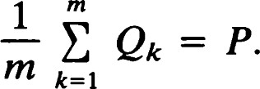

Proof: First note that

Qk = P + ak(Q - P), where a = rot (2T/m). Thus,

EQk = mp + - P).

The proof normally used to derive the formula for the sum of a geometric series applies here to show that the matrix equation

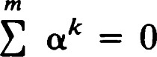

k=l holds. This completes the proof.

Theorem 12. Let {Qk} be the vertices of a regular m-gon. Let = QkQk+1 be a line determined by consecutive vertices. Then the whole polygon lies on the same side of Ck.

Proof: Let v = Qk — P. Then, we may write

= P + (rot O)v, Q] = P + (rot ö)v, where 0 = 2T/m and 6 = (j — k)0. Now

 = (rot 0 — 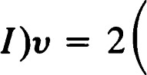sin J rot — 

Regular polygons

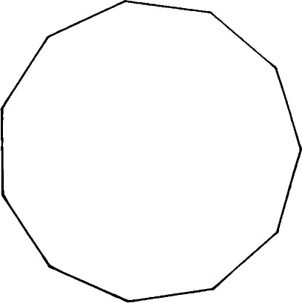

Figure 3.1 A regular Il-gon — symmetry group is dihedral.



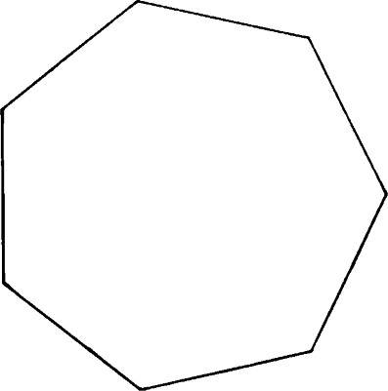

Figure 3.2 A regular 7-gon — symmetry group is dihedral.

and

 = 2 sin J rot —

The equation of the line is



where N = J(Qk+1 — Qk). We compute

Qk, N) = 4 sin — sin — J rot —  rot — v

= 4 sin — sin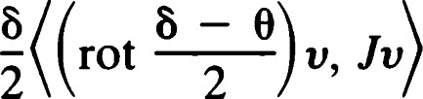

because J2 = —I and J = rot (T/2) commutes with the other rotations. But

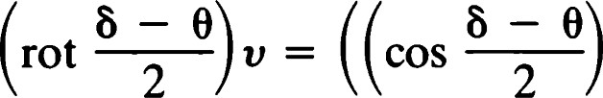I + sin 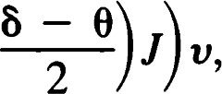

therefore,

(Q] — Qk, N) — 4 sin 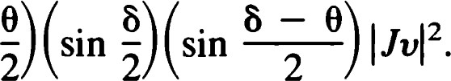

At this stage we remark that sin(ö/2) and sin((8 — 0)/2) cannot have different signs. At worst, one can be zero, and the other nonzero. We conclude that (Qj — Qk, N) O for all j, and that all the Qj lie on the same side of Ck. Furthermore, equality occurs if and only if = O (i.e., Qj = Qk) orb = 0 (i.e., Qk+l)•

Corollary. The line e does not intersect any segment of the form QjQj+1 except for the following cases:

i. Q] = Qk, Qj+l = Qk+l, ii. Q] = iii. Qk = 0+1.

Corollary. The vertices of the polygon are precisely the m points {Qj},



## Similarity of regular polygons

When computing the symmetry group of a regular polygon, it is legitimate to assume that its center is at the origin and one of its vertices is at = (1, 0). The reason is that if and 9' are two regular m-gons, then g (9) and g are conjugate in J(E2). We will now justify this

78 statement.

Theorem 13. Any two regular m-gons are similar. Similarity of regular polygons

Proof: Let P, Q and P', Q' be, respectively, the center and a vertex of two regular m-gons and 4'. Then T -p" and T are regular m-gons congruent to and 9'. Let d) and 4' be chosen so that (rot (b)T-p9 and (rot 4')T-pØ' are regular m-gons centered at the origin with one vertex on the positive xraxis (i.e., the ray with origin 0 and direction vector El). Call the new polygons and 9 'o

Now if Q = (q, 0) and Q' = (q', 0), let S be the central dilatation given by

## q'

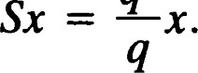

We claim that = 96. First note that if Qj and Q]' are the vertices of % and 96, respectively, then

SQ] = scot jo)Q = (rot je) C Q

= (rot jO)Q' = 

where 0 = 2T/m. Thus if qj and q; are the edges of and "6, respectively, then

sqj = q;•

We conclude that S % = .96. Putting all this together we see that

S(rot that is,



Theorem 14. The symmetry groups of any two regular m-gons are conjugate in M(E2).

Proof: Let T be the similarity constructed in the previous theorem. Then g (9) and SO are conjugate in the group of similarities. This is not enough. However, if g e g then

g = TpgoT -p, where go e 0(2). This is because g leaves P fixed. Now

TgT I

We observe that S commutes with every member of 0(2). Hence,

TgT—1  rgT-—1

where r is an isometry. This shows that g(4) and so(9') are in fact conjugate in '(E2).

## Symmetry of regular polygons

Theorem 15. Let be a regular m-gon. Then g (9) = Dm.

Proof: By Theorems 12 and 13 we may assume that the vertices of are of the form

(rot 21k)

Clearly, rot(21T/m) permutes the vertices. In fact,

21T

rot Qj •

Secondly, ref 0 permutes the vertices. Specifically,

(ref 0)Qj = Qm-J

Adjacent vertices remain adjacent under both of these transformations; In particular,

(rot qj = 0+1, (ref 0) qj = qm-j-l.

Thus, the edges are permuted by rot (2T/m) and ref O. Because each of these transformations is in we must conclude that C g But Leonardo's theorem shows that g(9) is cyclic or dihedral because the centroid must be left fixed. If g (9) contains a rotation other than those in Cm (call it rot 0), then rot 0 must permute the vertices. In particular, (rot O)Q must be a vertex and so must be equal to  for some j. Thus, rot 0 e Cm, and the proof is complete.

Leonardo's theorem together with Theorem 7 shows that the only groups that can occur as symmetry groups of rectilinear figures (having at least one vertex) are Dm and Cm.

The work on regular polygons shows that every dihedral group can be obtained as the symmetry group of some figure.

We now ask whether every cyclic group Cm can occur as the symmetry group of a figure. The answer can be seen as follows. A regular m-gon has 2m symmetries, m rotations, and m reflections. We change the figure in such a way as to destroy the bilateral symmetry while retaining the rotational symmetry. This can be done by attaching a tail to one end of

80 each of the edges.

Let Qj be defined as before, but let qj be the ray with origin Qj and direction vector Qj+l — Qj. One can check that no new vertices are introduced by this procedure. See Figures 3.3 and 3.4. However, (rot qj = qj+l and rot ?! Qj = Qj+l.

Thus Cm C g As before, these are the only rotations in g (F).

If any reflection ref 4) were a symmetry of F, it would have to permute the vertices of as well as leaving the centroid (the origin in this case) fixed. At most, two vertices could be fixed by ref (9. Thus, for some j * k, we would have

### Figures with no vertices

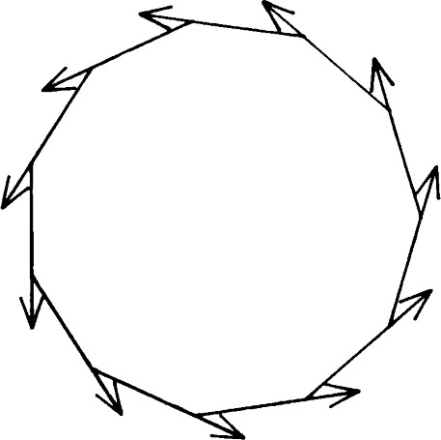

(ref 4)QJ = Figure symmetry 3.3 group A modified is cyclic.regular 11-gon —

Then

(ref — ref +(rot 0)Qj = rot(—0)(ref

= Qk-l.

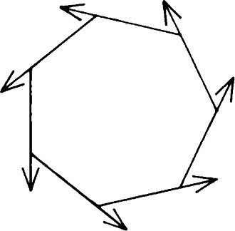Thus, ref sends the ray QjQj+1 to the ray QkQk-1, which is not in the figure 9. We conclude that 90 (9 ) contains no reflections, and g (+) = Cm. We can now state

Theorem 16. Every finite cyclic or dihedral group is the symmetry group of a rectilinear figure.

Figure 3.4 A modified regular 7-gon — symmetry group is cyclic.

Figures with no vertices

A complete rectilinear figure with no vertices must consist of a finite number of parallel lines. Let be such a figure, and let [v] be the direction of the lines.

Because Tv is a symmetry of F, we have an example of a rectilinear figure with an infinite symmetry group.

Theorem 17. Let ef be a figure consisting of a finite number of parallel lines with direction [v]. Let CT be the set of translations in g (F). Then eT = {Twlw e [V]}.

Proof: is the union of lines of the form P + [v]. Now



On the other hand, if e F, then TWP = P + w must be in P + [v]. Thus

Theorem 18. Let f be the figure of Theorem 17. Then g (F) n 0(2) has at most four elements.

Proof: Let A be a member of the group in question. Because A permutes the lines of F, we must have Av = ±v. Thus, A is a symmetry of the segment joining v and —v. By Theorem 2.28 there are at most four possibilities: two reflections, a half-turn, and the identity. In our case the identity and the reflection that interchanges v and —v necessarily belong to g(F). The other two transformations will belong only if the lines are placed in a certain way.

Theorem 19. Let 9 be a complete rectilinear figure with no vertices, and let  be the set of translations in SO (F). Then

i. ET is a normal subgroup of g ii. g (9)/$ has at most four elements.

Proof: The homomorphism that sends each symmetry onto its linear part has $ as its kernel and g (f) n 0(2) as its range. Thus, Sis normal, and the quotient group is isomorphic to g (f) n 0(2).

# EXERCISES

1. A parallelogram is a rectilinear figure consisting of four segments (sides) AB, BC, CD, and DA, where ABIICD and BCIIDA. Prove that there is an affine transformation relating any two parallelograms.
2. Find the affine symmetry group of the parallelogram.
3. A rhombus is a parallelogram in which all four sides have equal lengths. A rectangle is a parallelogram in which adjacent sides are perpendicular. A parallelogram that is both a rhombus and a rectangle is called a square. Find the symmetry groups of all types of parallelograms.
4. Let e be a line. Show that TRANS (C) U {HAP e C} is a group, and write down a multiplication table for it. Show that TRANS (C) is a normal subgroup, and describe the quotient group.
5. Let P and Q be distinct points. Describe the group G generated by {Hp, HQ}. Show that the set of translations in G is a normal subgroup and describe the quotient group.
6. Let be the union of three segments AB, BC, and CD. Given that d(A, B) = d(C, D), AB L BC, and BC i CD, what can you say about
7. Let F be a complete rectilinear figure having two or more vertices, all

82 of which are collinear. Show that so(9) is a finite group having one, two, or four elements. Describe the configuration in each of these cases.

8. Verify the equation ak = O in Theorem 11.

## Figures with no vertices